Contents

Step1 Create Company 2

Step2 Create Company Stylings 3

Step3 Create a new Group (used for assignment group) 6

Step4 Create chat queue 8

Step 5 Create Multiple Language Chat Queue 9

Step6.1 Create Chat Agent 9

Step6.2 Create Customer 12

Step6.3 Create Chat Supervisor 13

Step7 Round Robin Configs 15

# Step1 Create Company

Navigate to Organization->Companies

Click New

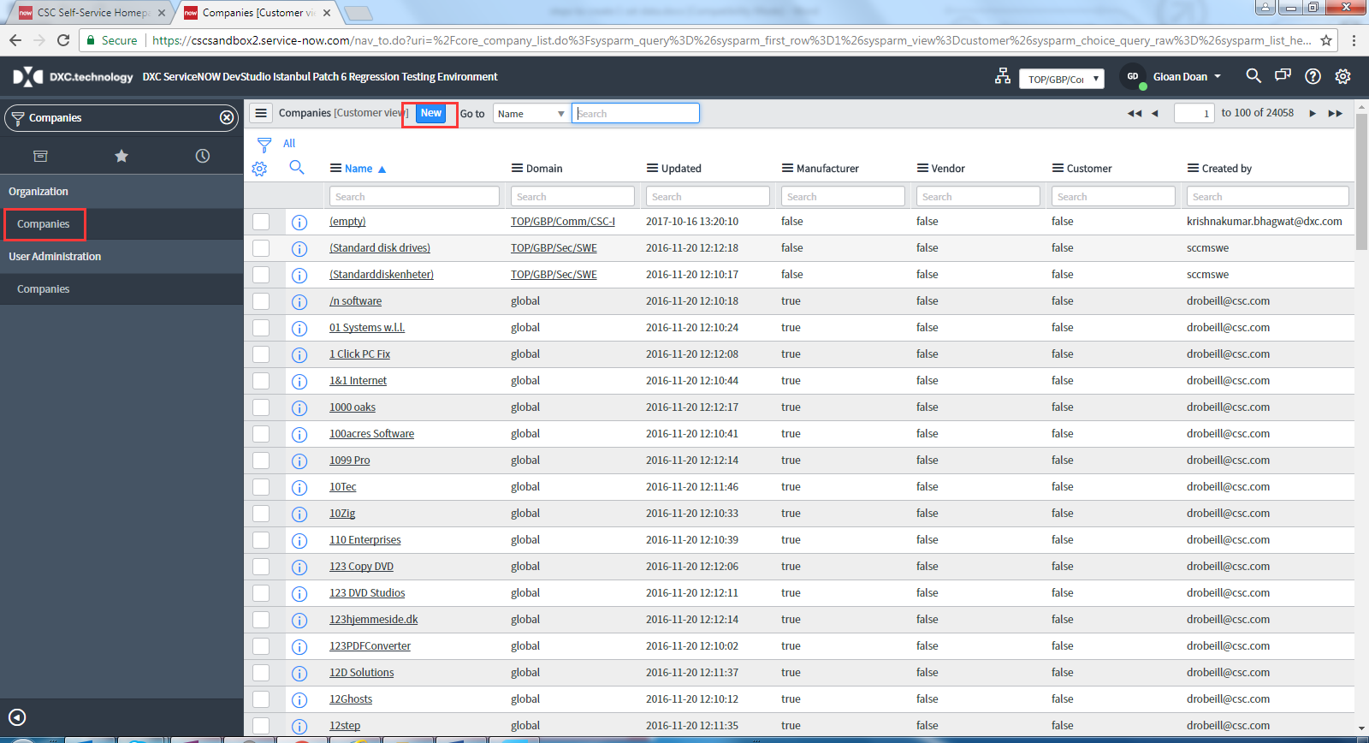

Name, such as “PT_COMPANY_0011”

Click Submit button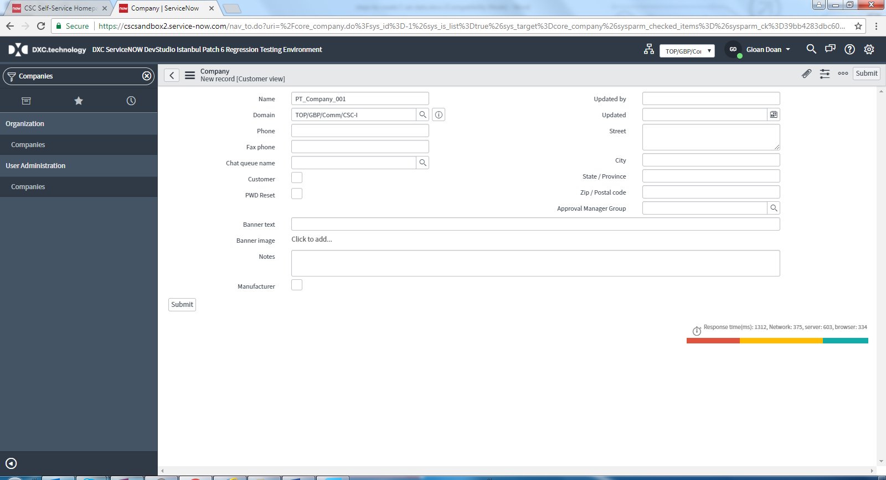

# Step2 Create Company Stylings

Navigate to CSC Run And Maintenance->Portal Configuration->Company Stylings

Click New

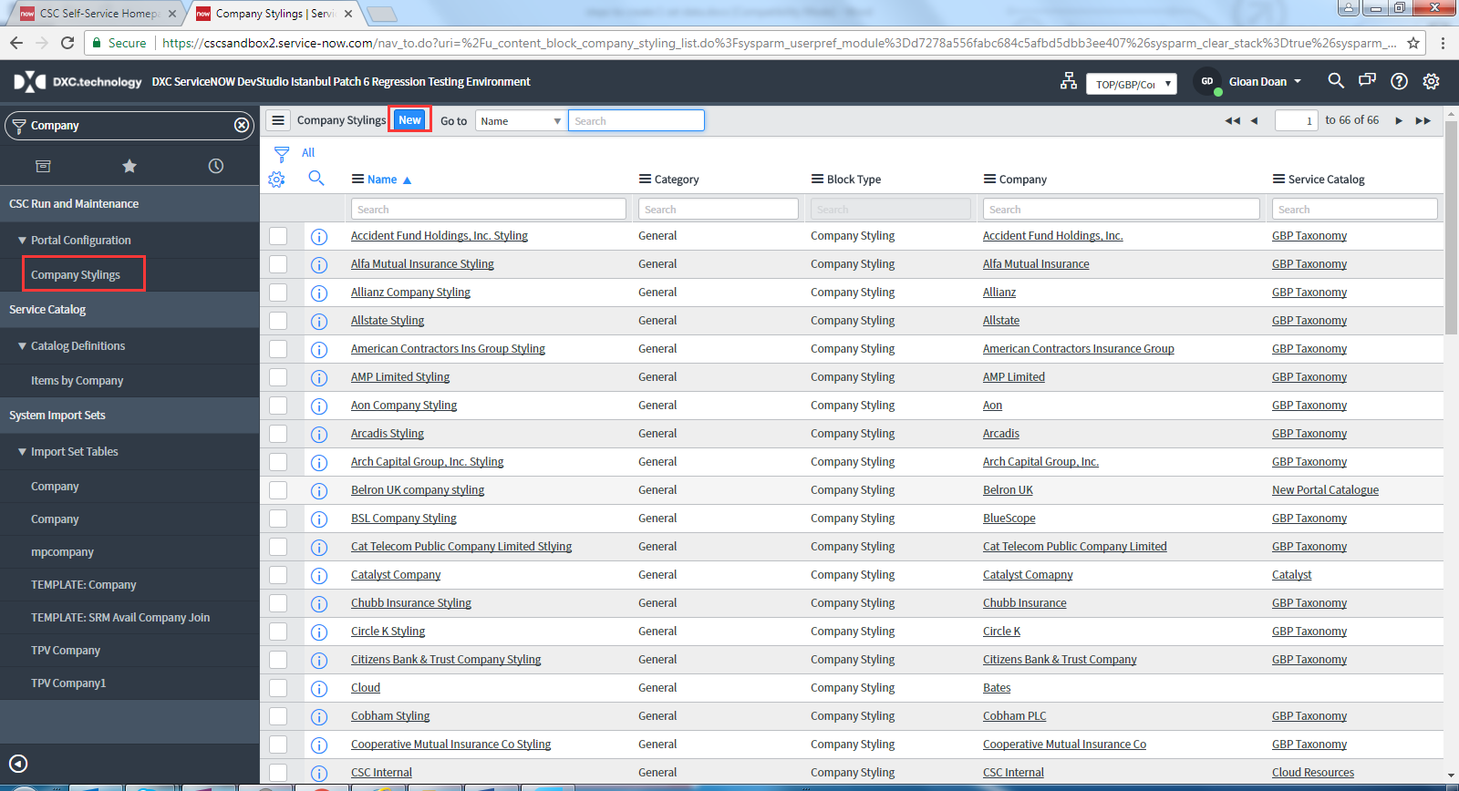

Name, such as “PT_COMPANY_0011_Styling”

Portal Name, such as “PT_COMPANY_0011_Styling”

Company, such as “PT_COMPANY_0011”

Site: CSC Self-Service

Tick all checkbox in right handside (Clear Cache, Chat, Active must be checked)

Click Submit Button

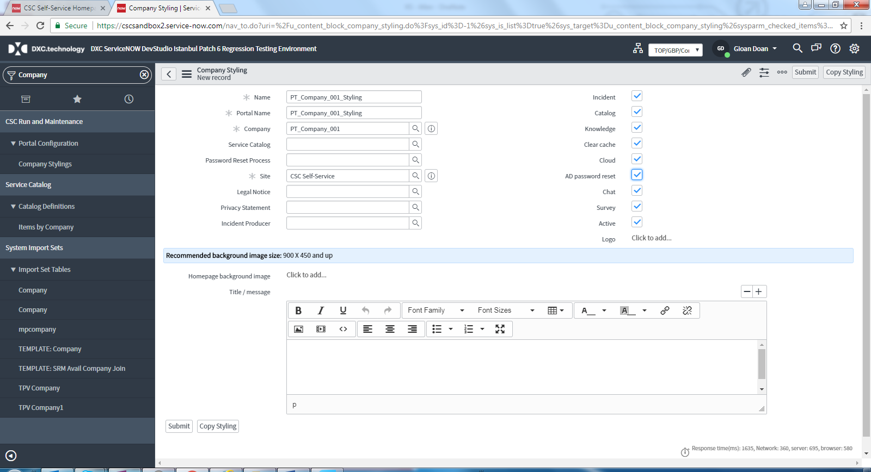

Below steps is to add navigate bar on the top of the self service screen.

Enter this company styling again to update

Click copy styling button

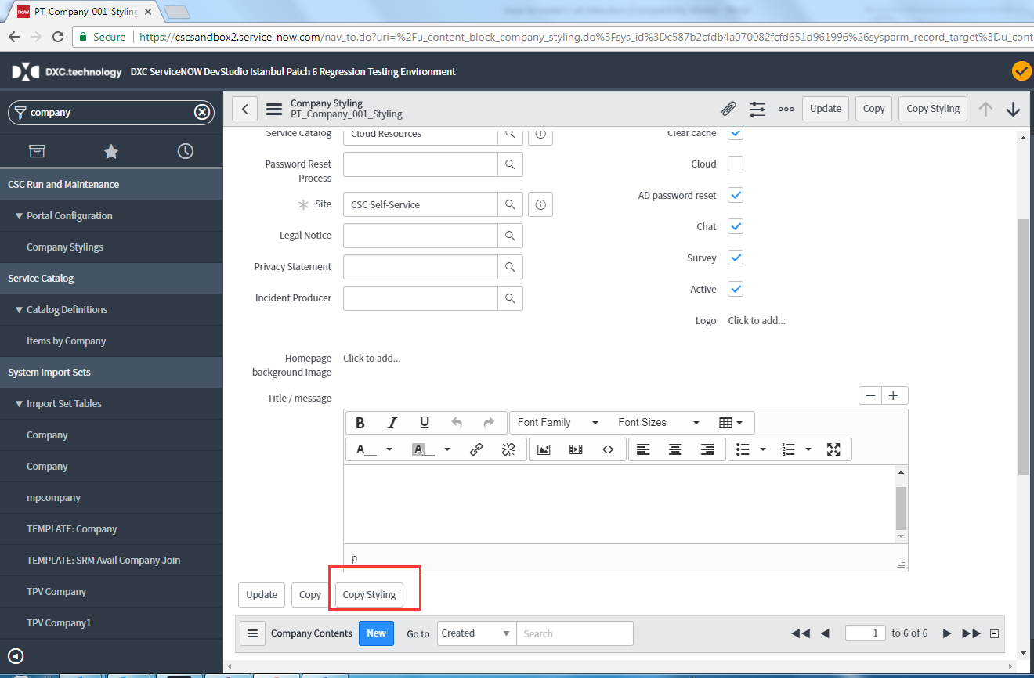

Click Copy button

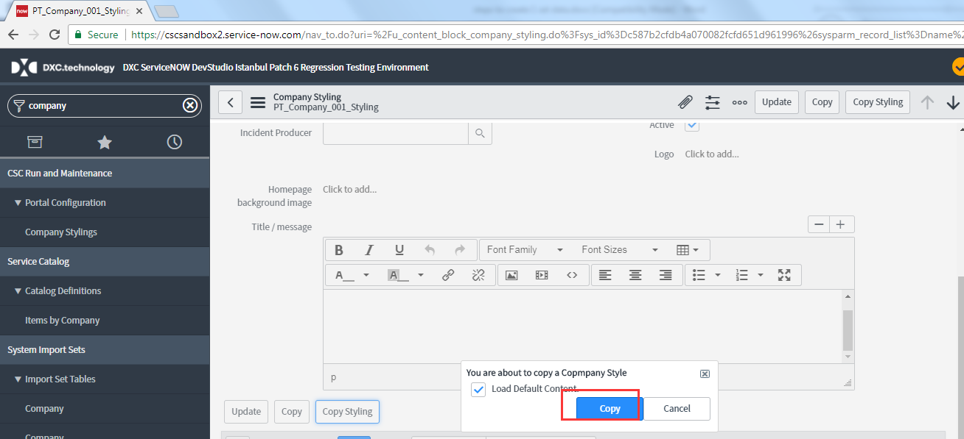

Click Update button

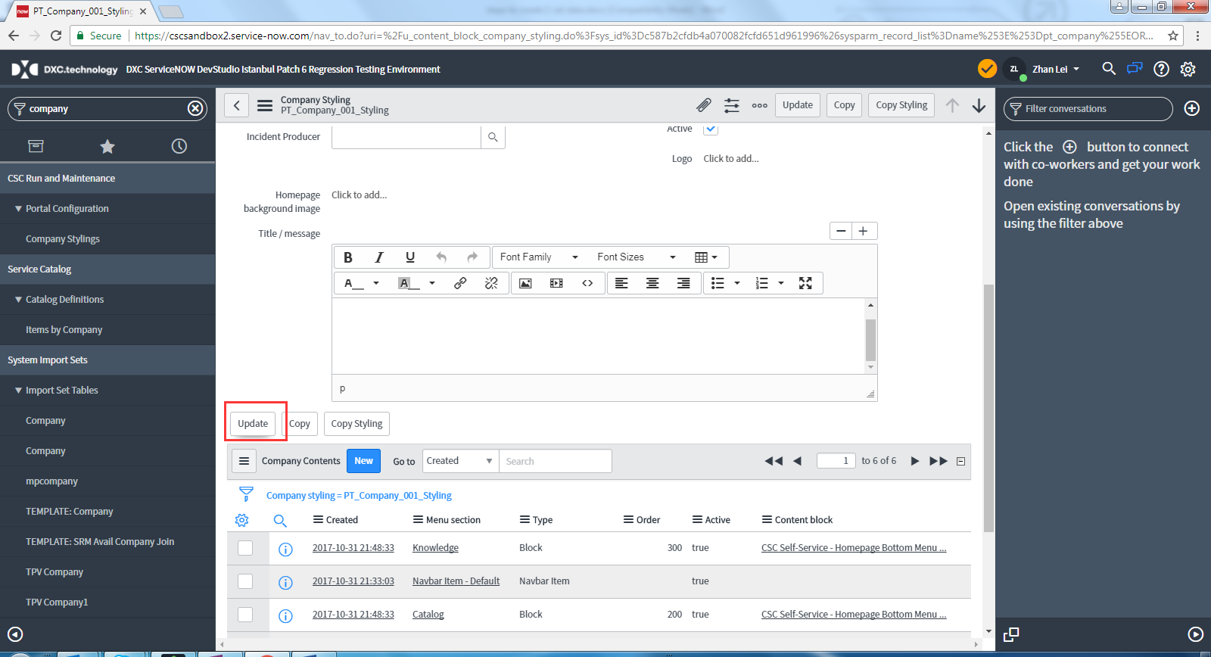

# Step3 Create a new Group (used for assignment group)

Navigate to Administration->Groups

Click New

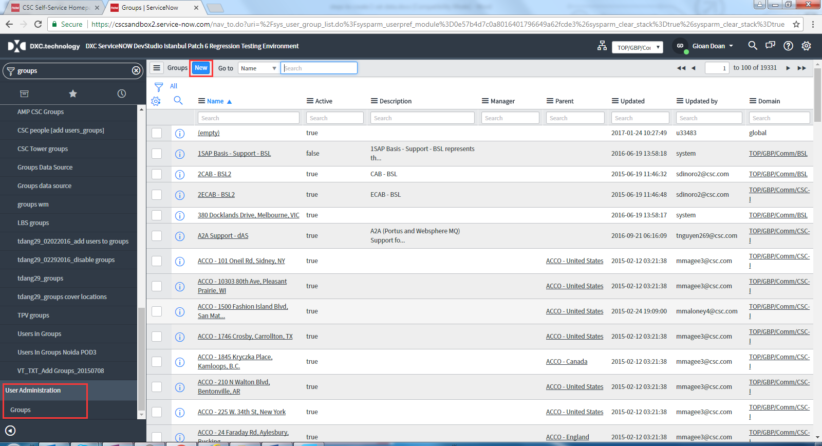

Name: such as “PT_CHAT_GROUP_0011”

Company: The Company created before, such as “PT_COMPANY_0011”

Type: Support

Active: ticked

Managed domain: TOP/GBP/Comm/CSC-I

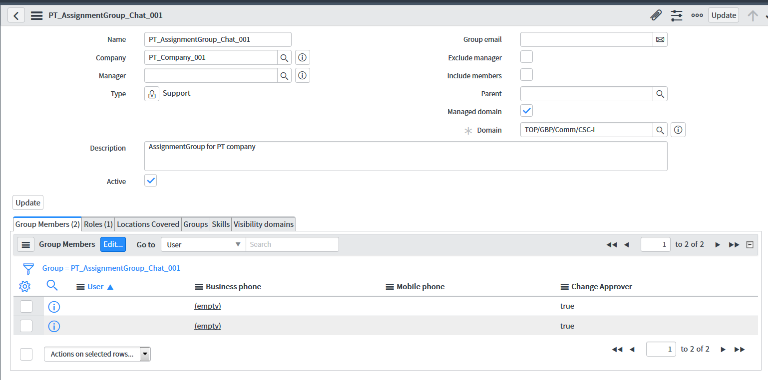

# Step4 Create chat queue

Navigate to Social IT->Chat->Chat Administration->Queues

Click New

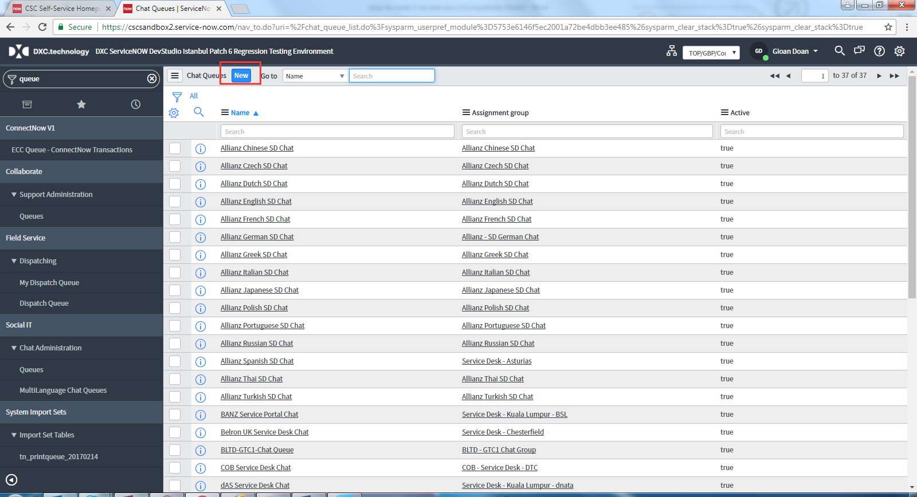

Name: the queue name, such as “PT_CHAT_QUEUE_0011”

Assignment group: the assignment group you created before, such as “PT_CHAT_GROUP_0011”

Schedule: 24x7x365

Initial agent response: Thank you for contacting support. An agent will be with you shortly.

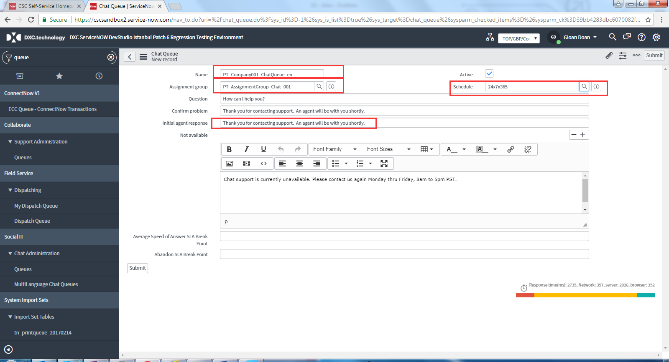

Step 5 Create Multiple Language Chat Queue

Navigate to Social IT->Chat->Chat Administration->MultiLanguage Chat Queues

Click New

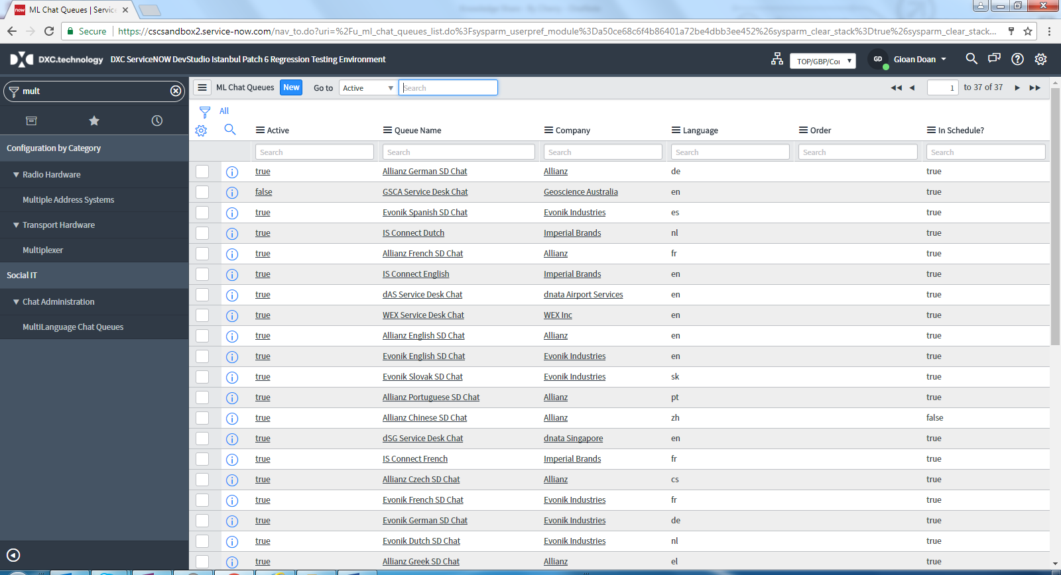

Queue Name: the queue name created before, such as “PT_CHAT_QUEUE_0011”

Company: The Company created before, such as “PT_COMPANY_0011”

Tick Active and Is schedule

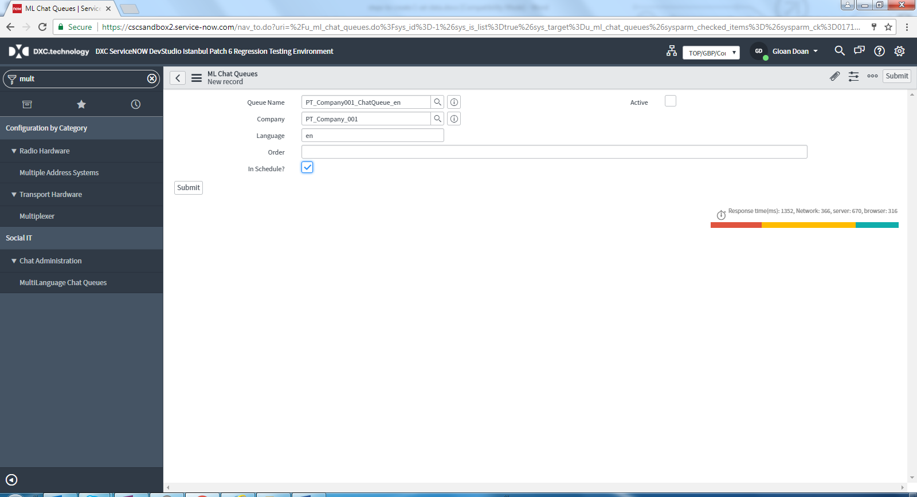

# Step6.1 Create chat agent

Navigate to User Administration->Users

Click New button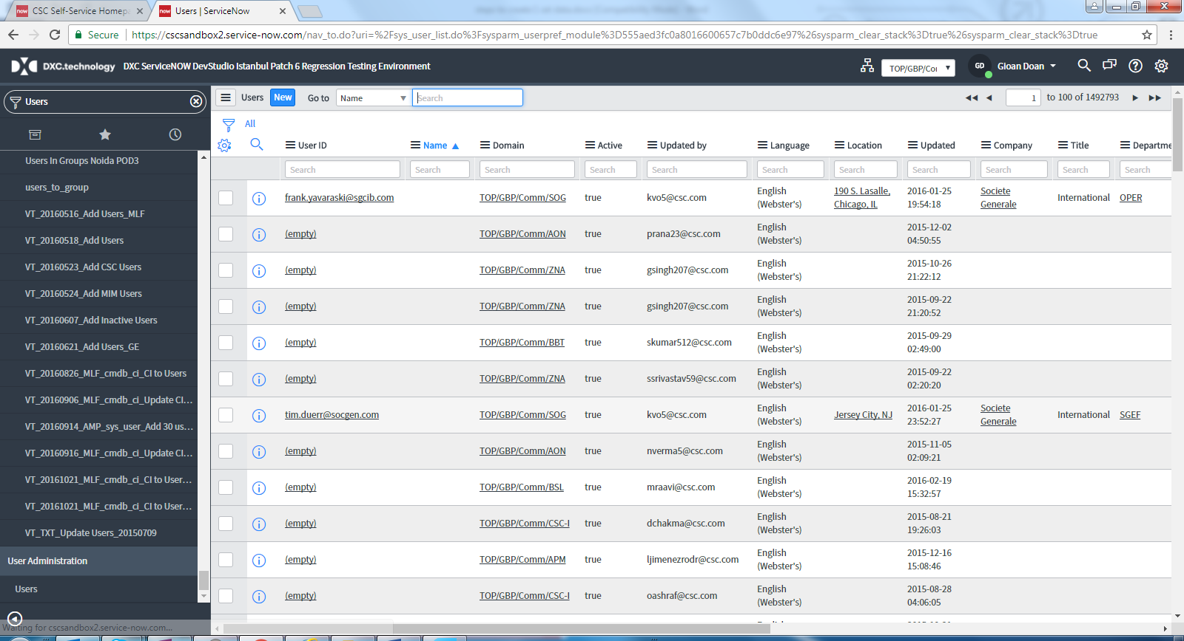

Fill values for User ID, such as “PT_CHAT_AGENT_USER_0011”

First Name, such as “PT_CHAT_AGENT_USER”

Last Name, such as “0011”

Choose Company you created before, such as “PT_COMPANY_0011”

Set Password, such as “Password123!”

Email, such as “PT_CHAT_AGENT_USER_0011@TEST.COM”

Click Submit Button.

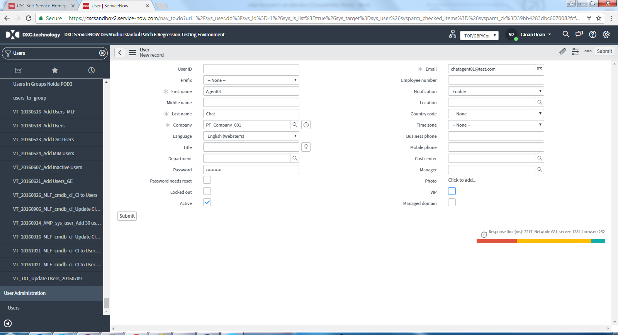

After clicking submit button, filter out this user (can use company to filter out) and continue to edit this user to go to Group sub tab->Edit to add group

To add group SEC: Service Desk and Assignment group you’ve created, such as “PT_CHAT_GROUP_0011”

Click Save button

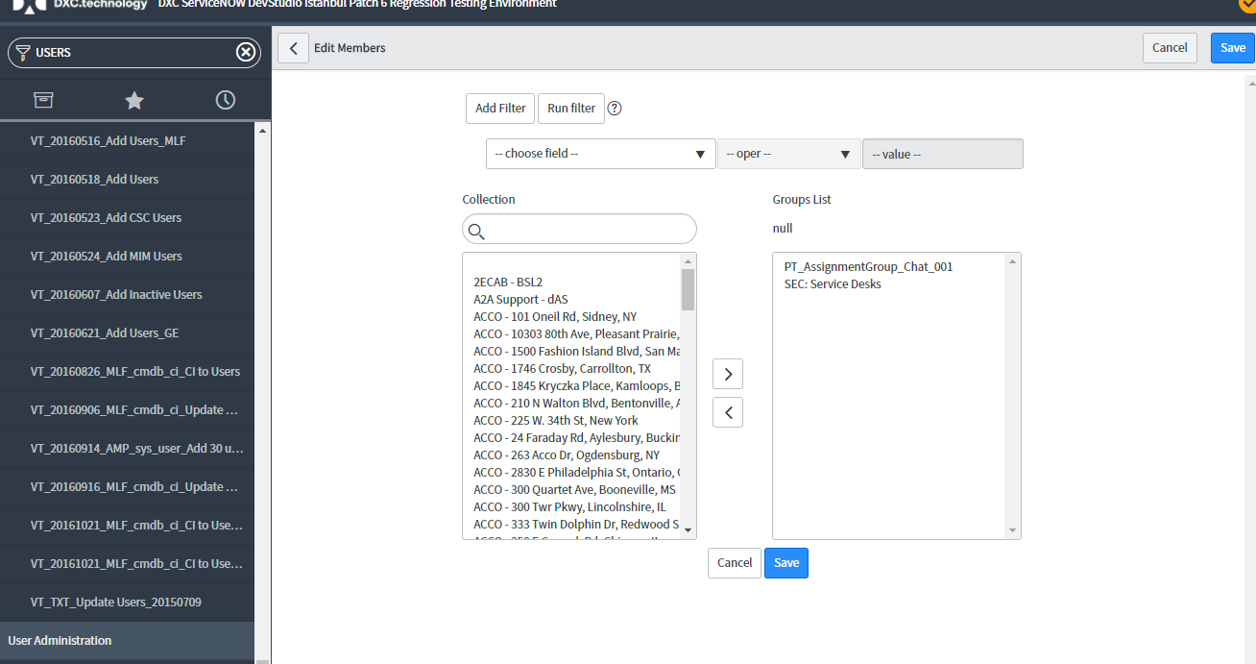

Click Update button

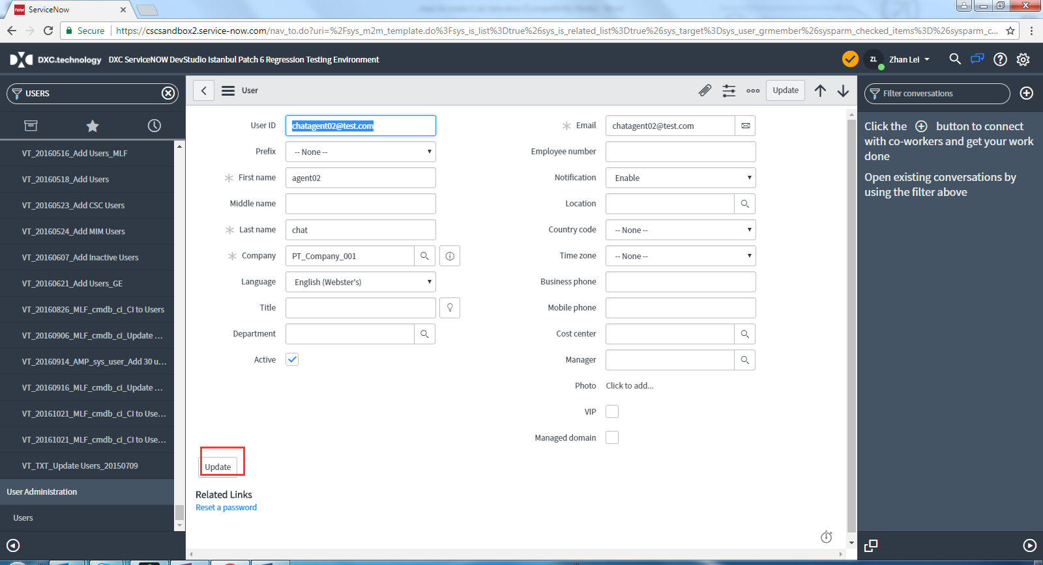

# Step6.2 Create Customer

Navigate to User Administration->Users

Click New button

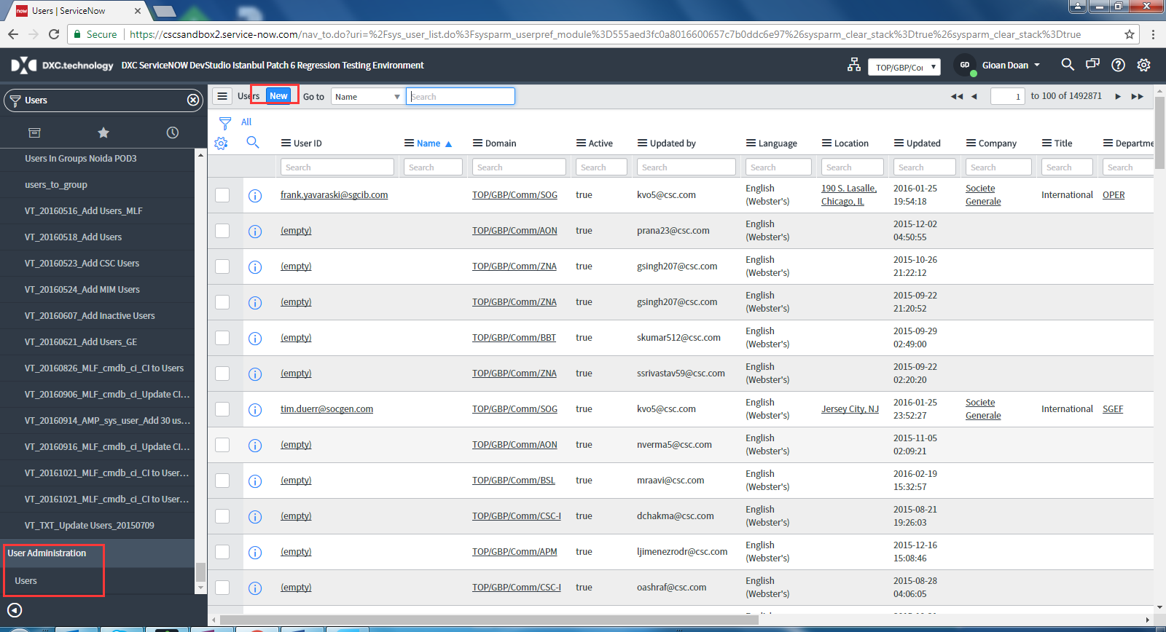

Fill values for User ID, such as “PT_CHAT_CUSTOMER_USER_0011”

First Name, such as “PT_CHAT_CUSTOMER_USER”

Last Name, such as “0011”

Choose Company you created before, such as “PT_COMPANY_0011”

Set Password, such as “Password123!”

Email, such as “PT_CHAT_CUSTOMER_USER_0011@TEST.COM”

Click Submit Button.

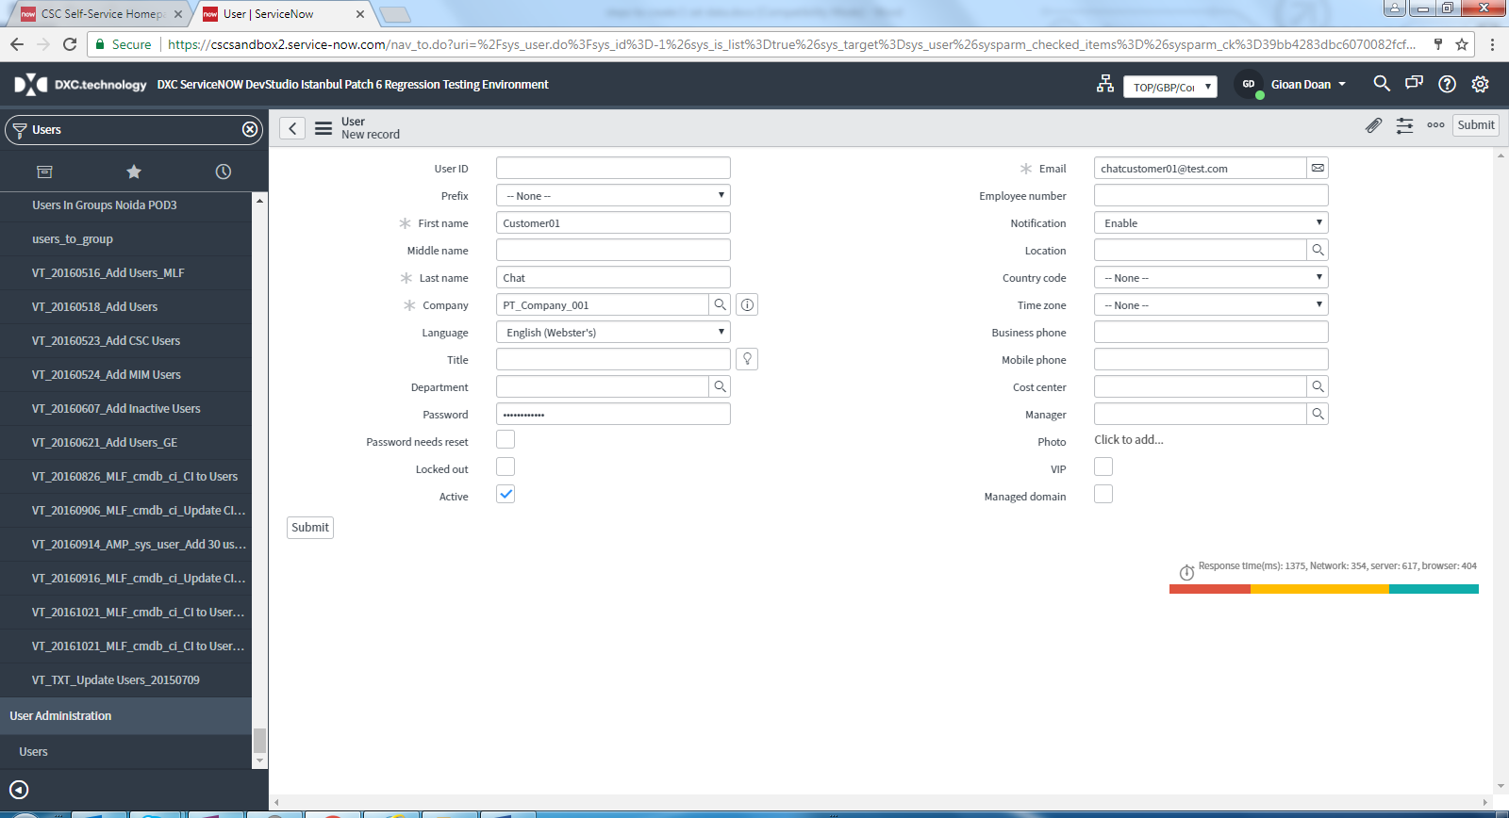

# Step6.3 Create Chat Supervisor

Navigate to User Administration->Users

Click New button



Fill values for User ID, such as “PT_CHAT_SUPERVIOR_USER_0011”

First Name, such as “PT_CHAT_SUPERVIOR_USER”

Last Name, such as “0011”

Choose Company you created before, such as “PT_COMPANY_0011”

Set Password, such as “Password123!”

Email, such as “PT_CHAT_SUPERVIOR_USER_0011@TEST.COM”

Click Submit Button.

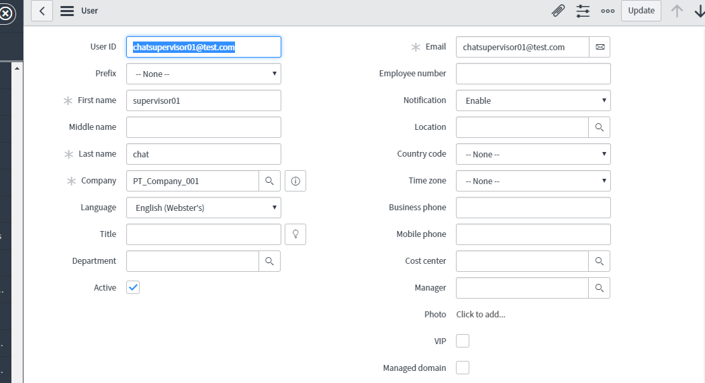

After clicking submit button, filter out this user and continue to edit this user to go to Group sub tab->Edit to add group

To add group SEC:”ITIL Managers” and Assignment group you’ve created such as “PT_CHAT_GROUP_0011”

Click Save button

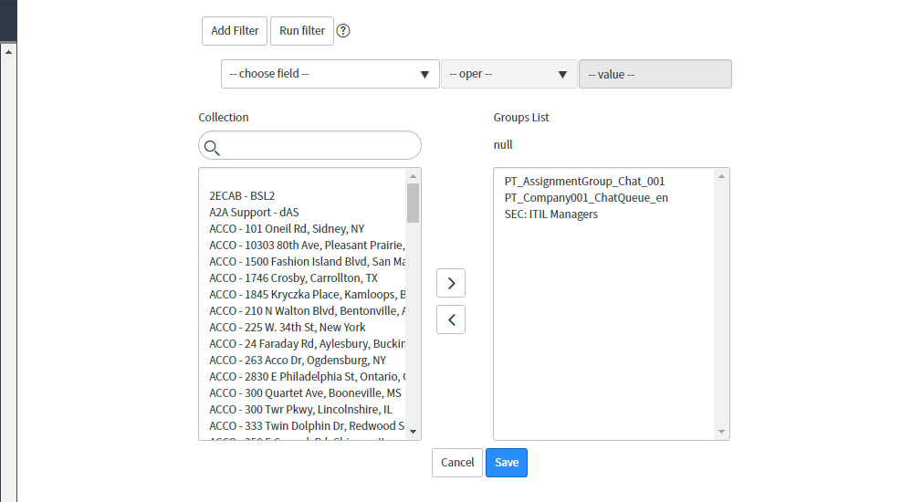

Click Update Button

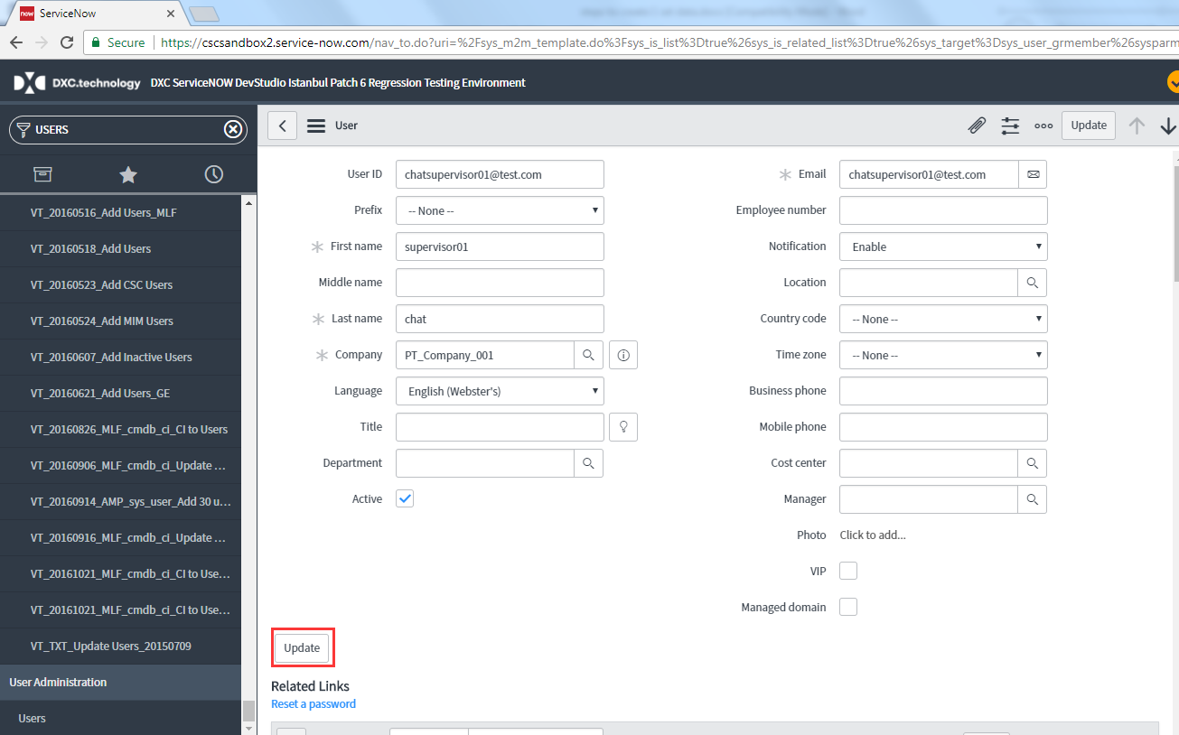

# Step7 Round Robin Configs

Login or switch to Chat Supervior which created just now (Such as “PT_CHAT_SUPERVISOR_USER_0011”), and Navigate to Chat Round Robin-> Chat Round Robin Configs

Click import Agents Button

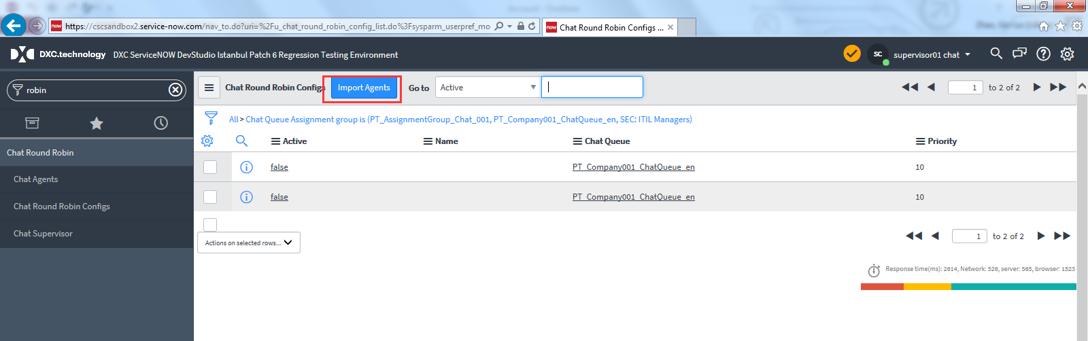

Choose the record which Chat Queue is the Agent you have created before, such as “[PT_CHAT_QUEUE_0011](https://cscsandbox2.service-now.com/chat_queue.do?sys_id=4a774d00db5e0b0082fcfd651d9619d7)”.

Tick Active.

